Test Report

Test for the user story:
As a contributor, I shall be able to upload files, so that it can be posted if relevant.

The AllArticle Table in the database before up load:

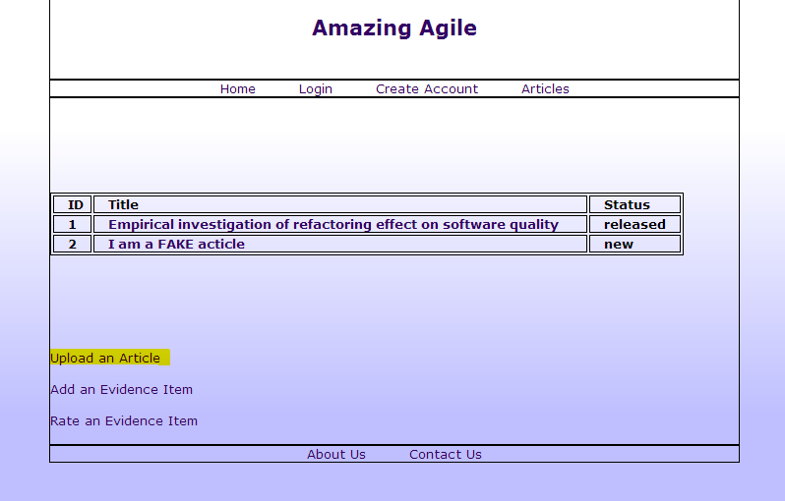
Click on “Upload an Article”
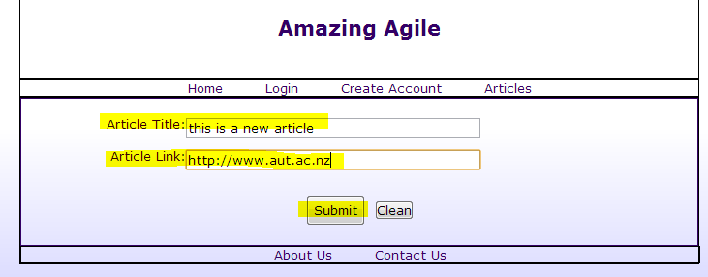
Enter the title and the link of the article and click “Submit”
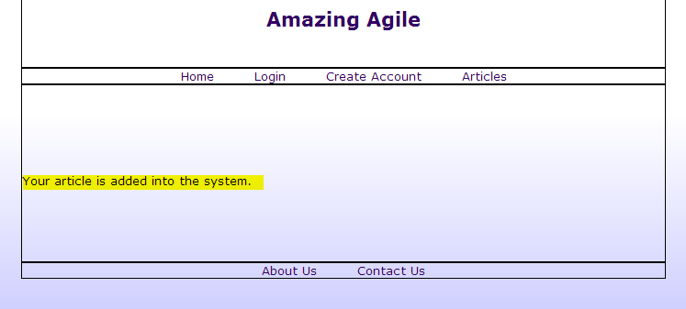
Get a notification to confirm the article is added.
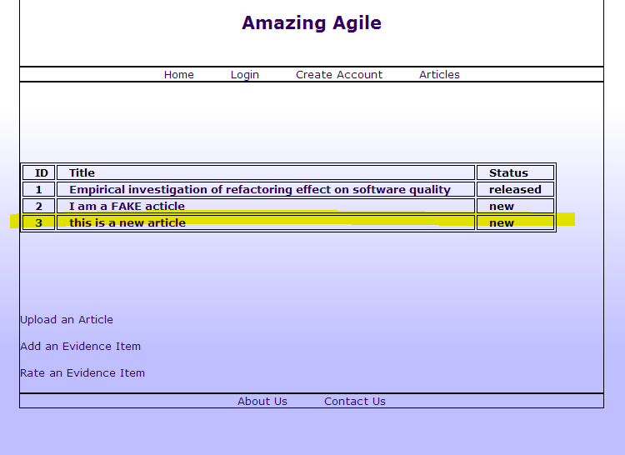
The new article is display in the list
The article is added to the database.

Test Passed.

Test for user story:
As an analyst, I want to enter the evidence item for an article, so that I can store the data of the article into the system.

The EvidenceItem Table in the database before new evidence item added:
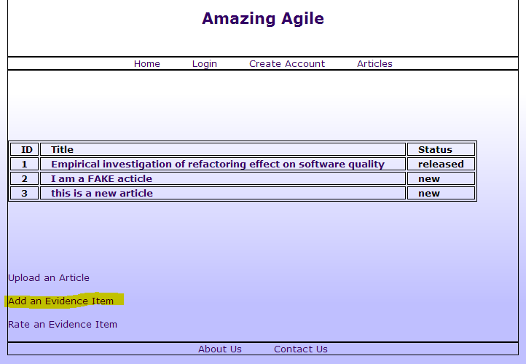
Click on “Add an Evidence Item”
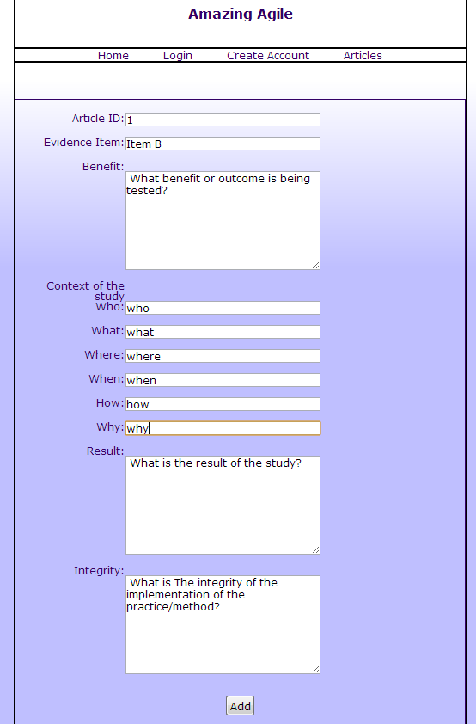
Fill in the form and click “Add”
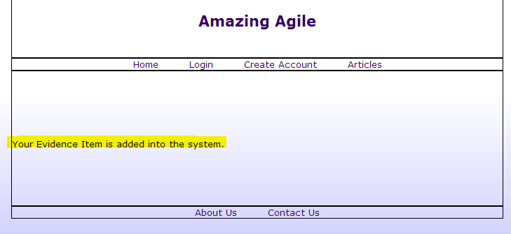
Get a notification to confirm the evidence item is added.

The evidence item is added into the EvidenceItem Table in the database

Test Passed.

Test for user story:
As an analyst, I want to be able to enter the Confidence Rating of the article so that I can store the information of the article into the system

The Confidence Table in the database before new rating added:
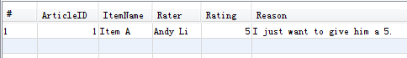
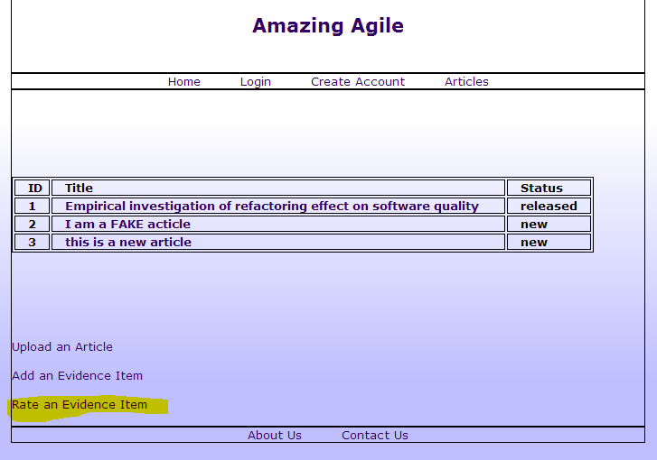
Click on “Rate an Evidence Item”
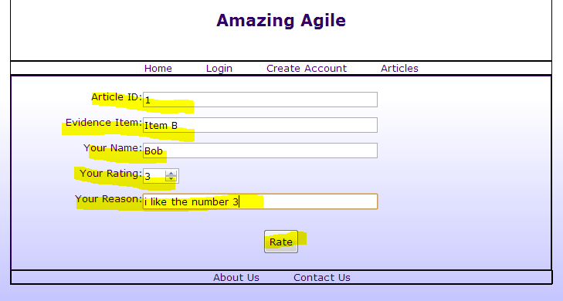
Fill in the form and click “Rate”
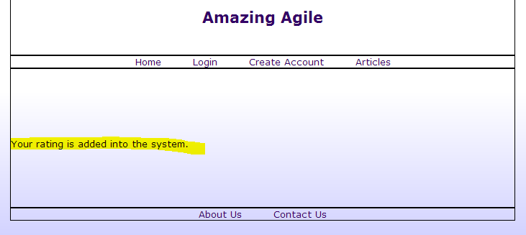
Get a notification to confirm the rating is added.

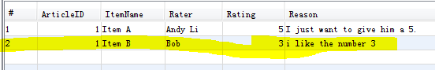
The rating is added into the Confidence Table in the database

Test Passed.

